**Hdfs commands**

**1. Print the Hadoop version**

**hadoop version**

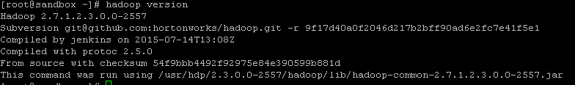

**2. List the contents of the root directory in HDFS**

**hadoop fs -ls /**

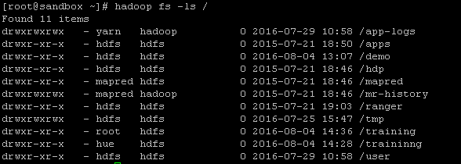

**3. Report the amount of space used and available on currently mounted filesystem**

**hadoop fs -df hdfs:/**



**4. Count the number of directories,files and bytes under the paths that match the specified file pattern**

**hadoop fs -count hdfs:/**



**5. Create a new directory in HDFS.**

**hadoop fs -mkdir /training**



**6. Add a sample text file from the local directory named “data” to the new directory you created in HDFS during the previous step.**

**hadoop fs -put /data/sample.txt /training**



**7. List the contents of this new directory in HDFS.**

**hadoop fs -ls /training/**

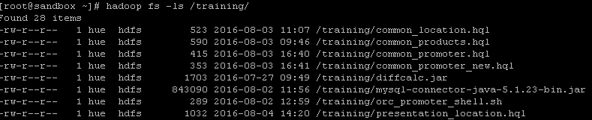

**08. Add the entire local directory called “retail” to the /training directory in HDFS.**

**hadoop fs -put /data/retail /training/**



**09. See how much space this directory occupies in HDFS.**

**hadoop fs -du -s -h /training**



**10. Delete a file ‘retail’ from the “training” directory.**

**hadoop fs -rmr /training/retail**



**11. Delete all files from the “retail” directory using a wildcard.**

**hadoop fs -rm /retail/\***



**12.To empty the trash**

**hadoop fs –expunge**



**13. Finally, remove the entire test directory and all of its contents in HDFS.**

**hadoop fs -rm -r /test/demo/one**



**14. Add the purchases.txt file from the local directory named “/home/training/” to the hadoop directory you created in HDFS**

**hadoop fs -copyFromLocal /data/sample.txt /training/demo**



**15. To view the contents of your text file sample.txt which is present in your hadoop directory.**

**hadoop fs -cat /data/sample.txt**



**16. Add the purchases.txt file from “hadoop” directory which is present in HDFS directory to the directory “data” which is present in your local directory**

**hadoop fs -copyToLocal /training/sample.txt /home/training/data**



**17. cp is used to copy files between directories present in HDFS**

**hadoop fs -cp /training/sample.txt /user/training/hadoop**



**18. ‘-get’ command can be used alternaively to ‘-copyToLocal’ command**

**hadoop fs -get /training/hadoop/sample.txt /home/training/**



**19. Display last kilobyte of the file “purchases.txt” to stdout.**

**hadoop fs -tail /hadoop/purchases.txt**



**20. Default file permissions are 666 in HDFS Use ‘-chmod’ command to change permissions of a file**

**hadoop fs -chmod 777 /hadoop/purchases.txt**



**21. Move a directory from one location to other**

**hadoop fs -mv /hadoop /apache_hadoop**



**22. Copy a directory from one node in the cluster to another Use ‘-distcp’ command to copy,**

**-overwrite option to overwrite in an existing files**

**-update command to synchronize both directories**

**hadoop fs -distcp hdfs://namenodeA/apache_hadoop hdfs://namenodeB/hadoop**

**23.List all the hadoop file system shell commands**

**hadoop fs**

**24.The hadoop touchz command creates a zero byte file. This is similar to the touch command in unix. The syntax is shown below:**

**hadoop fs -touchz /path**

**25.Hadoop tail command prints the last kilobytes of the file. The -f option can be used same as in unix.**

**hadoop fs -tail /path**

**30. Run a DFS filesystem checking utility**

**hadoop fsck – /**

**31. Run a cluster balancing utility**

**hadoop balancer**



For ubuntu

scp demo.txt root@192.168.0.1:APRB2/demo.txt